Amelia Jane Hunter presents:

Hell West and Crooked

'An incredible talent, bold and daring' -The Age

Austral Hotel 6:30pm
2-14 March [6pm Sundays]

In 2009, Amelia had a fall from grace, hit her head on a rock and woke up in the Cook Islands on a Reality TV show

Forced to fight, she killed only with kindness and refused to cry on cue. Smart, audacious and aware of human rights, she discovered the hidden immunity idol, low production values and destructive forces early.

Welcome to Survivor- on a home brand budget.

Warning: Participation in Reality TV is a momentary lapse of intelligence

Dangerous, demented and downright hilarious, this is one show not to be missed!

"The horses are hell west and crooked − it’ll take a week to muster them”
- Tom Cole

Originally from Darwin, Amelia is now a Sydney based comedian/performer and television presenter. Her unique brand of energy filled character comedy provides hilarious insights into the wicked and wily workings of a well bred, lateral thinking mind.

Highly original and incredibly theatrical, her humour is both confronting, sensitive and intelligent, a hearty grain fed, well rounded, full bodied flavour with lashings of laughter and a generous side of political profanity.

‘Utterly hilarious’ - The Pun

Amelia’s brand of individual comedy has earned her top accolades and comedy awards both in Australia and abroad:

- 2008 Sydney Comedy Festival ‘Directors Prize’ Award
- 2008 Melbourne International Comedy Festival Award
- 2008 Adelaide Fringe Award Nomination
- 2007 Melbourne International Comedy Festival Award
- 2007 Edinburgh Fringe Festival Award Nomination
- 2006 Melbourne International Comedy Festival Award Nomination

‘A one woman tour de force!' - The Scotsman

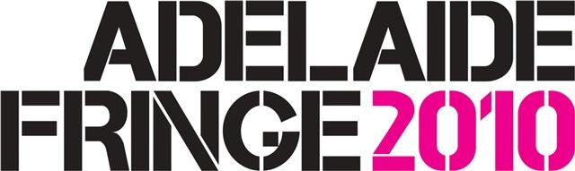
www.ameliajanehunter.com

